

Data Structures and Algorithms 23CSE203
LAB MANUAL

Submitted by
Name | M.HARSHAVARDHAN
Roll No | AV.SC.U4CSE25130
Year/Sem/Section | 2nd Year/3rd Sem/CSE-B
Credits | 5

Submitted to | Dr. Raj Kumar Batchu
Designation | Asst.Proffessor (SI.Grade)
Department | School of Computing

S.NO | TITLE | PAGE NO | REMARKS
1

WEEK -1

Aim:

Program:

def launch(n): if n>=1:
print(n) launch(n-1)
launch(10)
print('launch completed')

Negative Output:

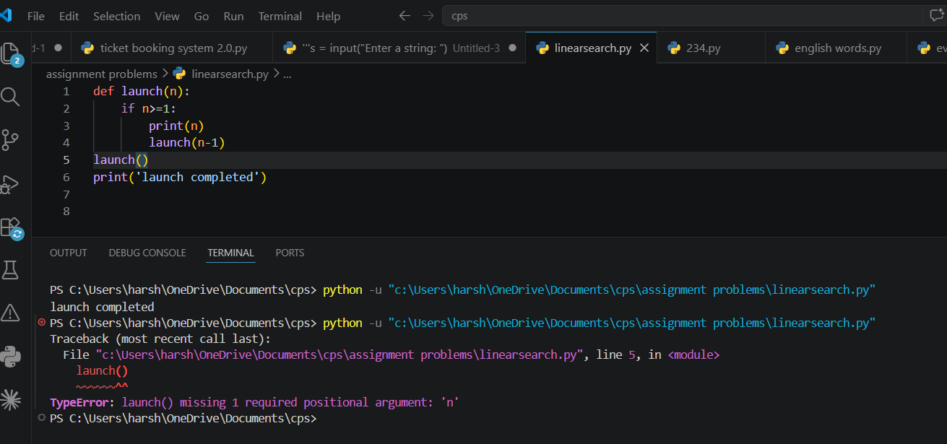

Output:
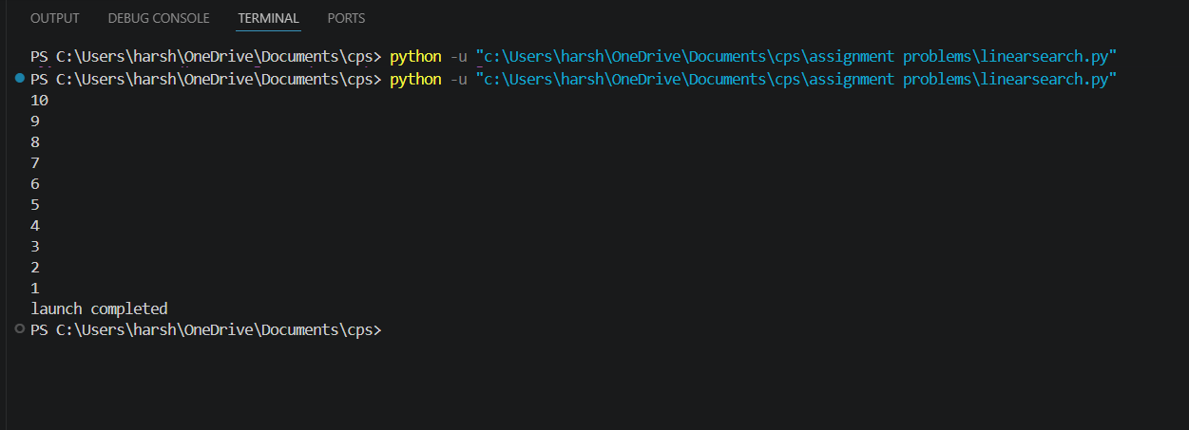

Explanation:
- Launch(10) starts the function with n = 10.
- if n >= 1 checks whether n is at least 1.
- print(n) prints the current value.
- launch(n-1) calls the function again with the value decreased by 1.
- This continues until n becomes 0; then the condition is false and recursion stops.
- Finally, "launch completed" is printed.
Output: 10 9 8 ... 1, followed by launch completed.

Error Table:

S.No | Error
1 | TypeError: launch() missing 1 required positional argument: 'n'

Aim:

Program:
def power(p,n):
if n==0:
return 1
else:
return p*power(p,n-1) p=float(input('get me the amount:\t')) n=int(input('agreed years:\t')) print(power(p,n))

Negative Output:
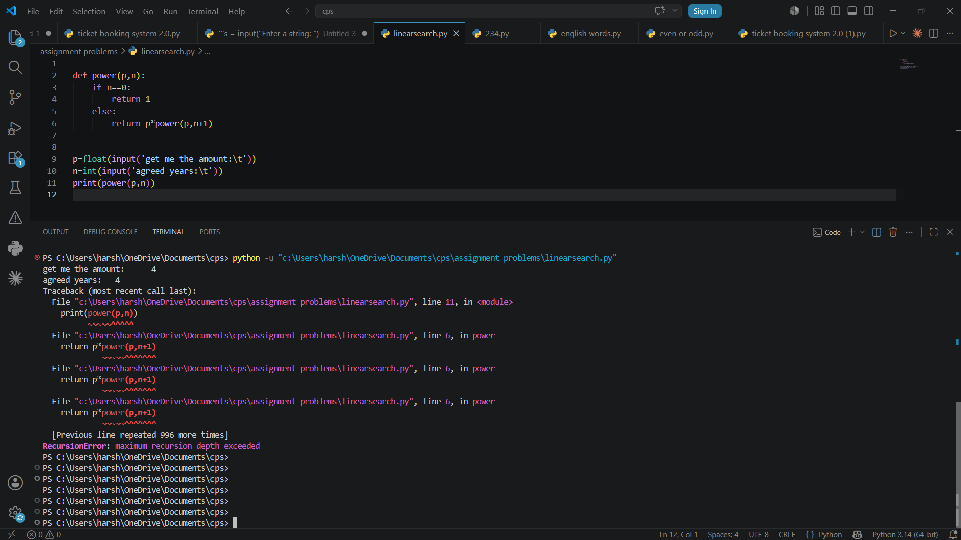

Output:
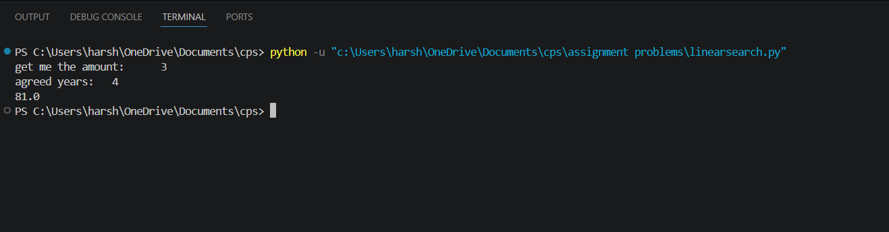

Explanation:
- Power(p, n) calculates p raised to the power n using recursion.
- If n == 0, it returns 1 because any number raised to 0 is 1.
- Otherwise, p * power(p, n-1) repeatedly multiplies p.
- The recursion continues until n becomes 0.
- p is taken as a float and n as an integer from the user.
- Finally, print(power(p,n)) displays the calculated power.

Error Table:

S.no | Error
1. | Recurrsion Error

Aim:

Program:
def search():
i=int(input('get me the id of employee:\t')) for n in range(len(emp)):
if emp[n]==i: print('employee found')
else:
print('no such id exist') emp=[101,102,103,104,105,106,107,108,109]
search()

Negative Output:
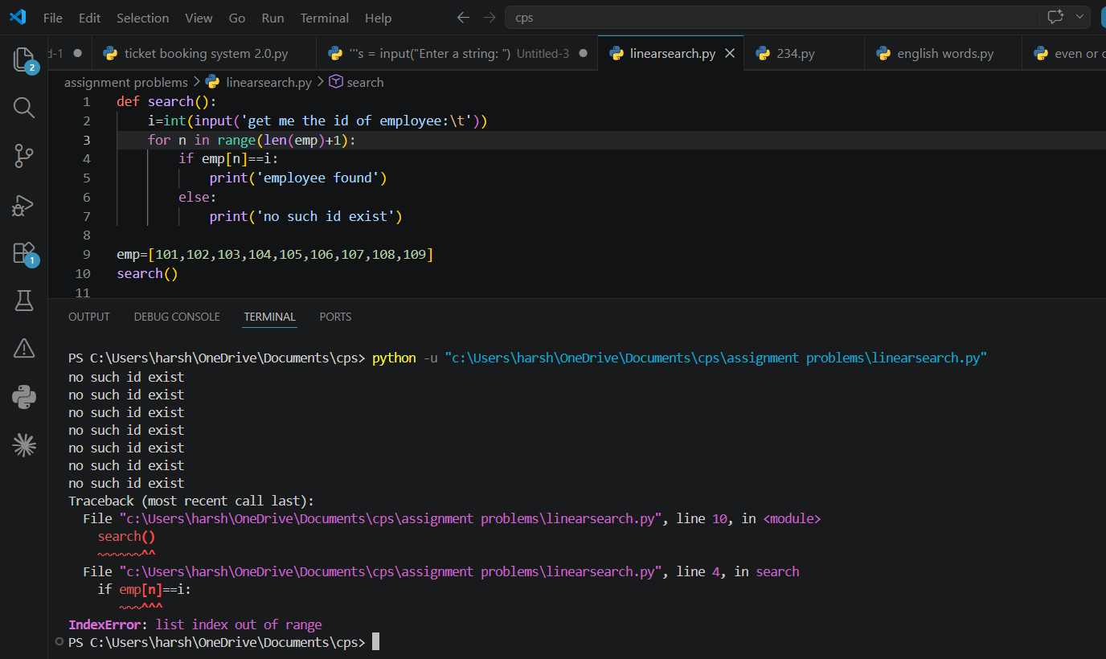

Output:

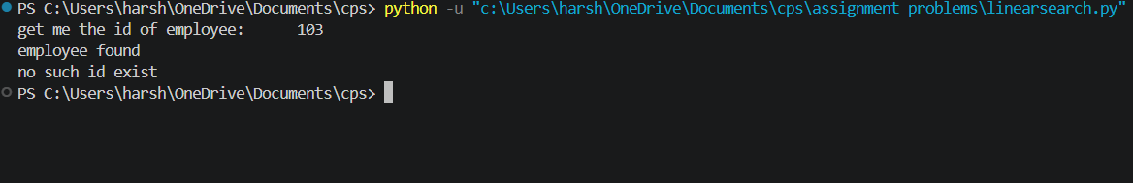

Explanation:
- emp stores the employee IDs.
- search() gets an employee ID from the user.
- for loop checks each ID in the list.
- if emp[n] == i checks whether the entered ID exists.
- If matched, it prints employee found.
- The else belongs to the for loop and executes after the loop completes.

Error Table:

S.no | Error
1. | IndexError: list index out of range

Aim:

Program:
def fib(n): if n == 0:
return 0 elif n == 1:
return 1 else:
return fib(n - 1) + fib(n - 2) def pfib(n,i):
if n==i:
return else:
print(fib(i)) pfib(n,i+1)

n = int(input("Enter the number of terms: "))

if n <= 0:
print("Wrong input") else:
i=0 pfib(n,i)

Output:

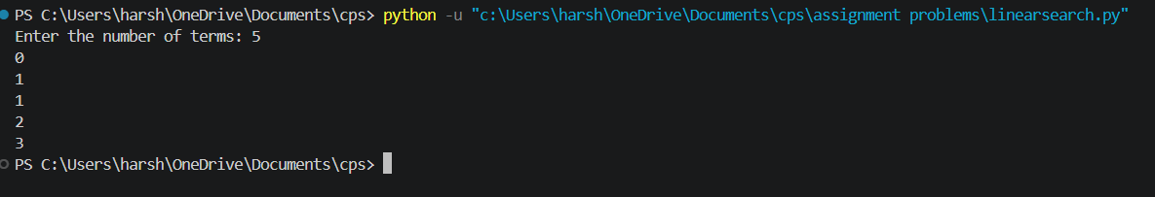

Explanation:
- fib(n) calculates the nth Fibonacci number using recursion.
- If n == 0, it returns 0.
- If n == 1, it returns 1.
- Otherwise, it calculates fib(n-1) + fib(n-2).
- pfib(n, i) prints Fibonacci numbers from position 0 up to n-1.
- When n == i, recursion stops.
- If the user enters 0 or a negative number, it prints Wrong input.

Aim:

Program:
def fact(n): if n==0:
return 1 elif n==1: return 1
else:
return n*fact(n-1)
n = int(input('Get me the number for Factorial calculate:\t')) print(f'Factorial of {n} is {fact(n)}')

Negative Output:
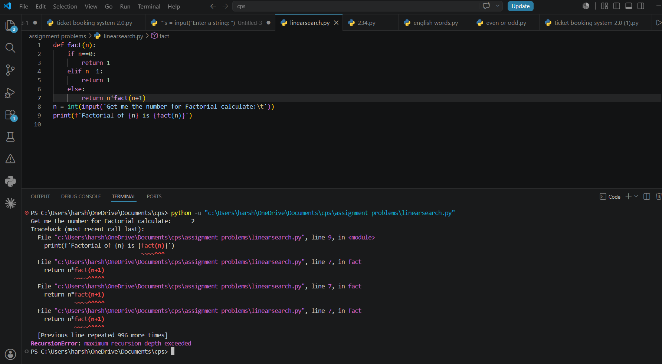

Output:
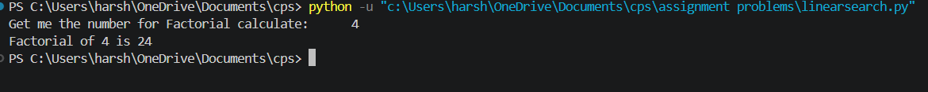

Explanation:
- fact(n) calculates the factorial of n using recursion.
- If n == 0 or n == 1, it returns 1 because 0! = 1 and 1! = 1.
- Otherwise, it calculates n * fact(n-1).
- The function keeps calling itself with n-1 until it reaches 0 or 1.
- The user enters the number, and the final factorial is printed.

Error Table:

S.no | Error
1. | RecursionError: maximum recursion depth exceeded

Week-2
Aim: Code for Linear Search

Program:
def linear(arr, key):
for i in range(len(arr)): if arr[i] == key:
return i return -1

def main():
n = int(input("get me the size of list:\t"))

if n <= 0:
print("Try again ")
return

arr = []

for i in range(n):
s = int(input(f"get me the element {i+1}:\t")) arr.append(s)

key = int(input("get me the value to search:\t"))

if linear(arr, key) != -1:
print(f"The {key} is found in array") else:
print("Not found")

main()

Negative Output:
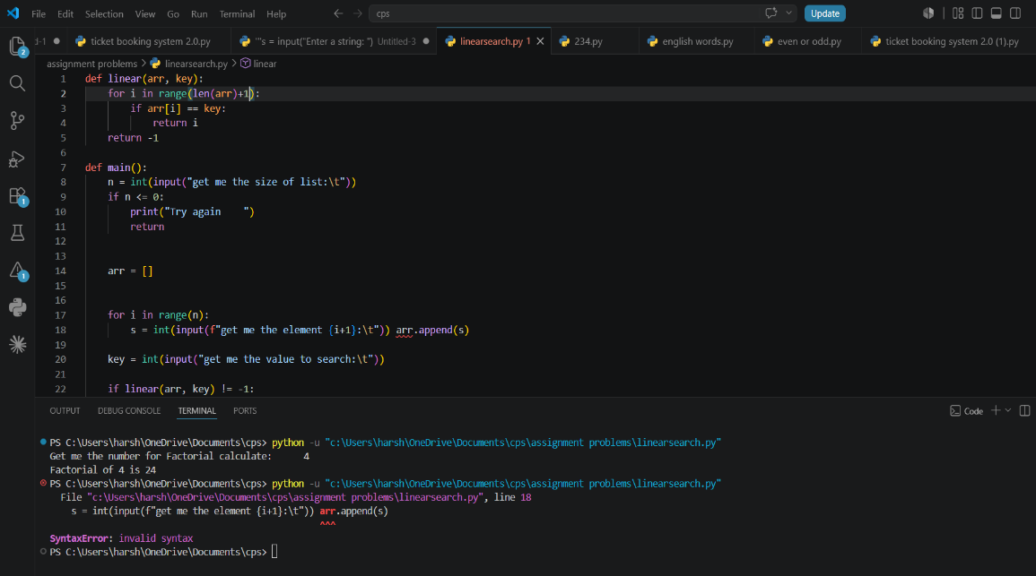

Output:

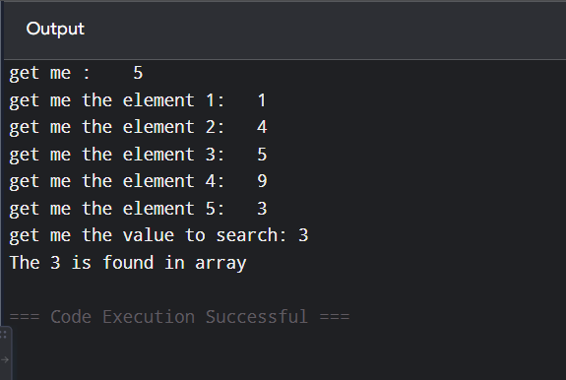

Explanation:
- linear(arr, key) performs a linear search on the array.
- The for loop checks every element one by one.
- If arr[i] == key, it returns the index i.
- If the key is not found, it returns -1.
- main() gets the size of the list and its elements from the user.
- It then gets the value to search and calls linear().
- If the returned value is not -1, it prints found; otherwise, it prints Not found.
- If the size n is 0 or negative, it prints Try again and stops.

Error Table:

S.no | Error
1. | SYNTAX ERROR

Aim: Code for Binary search if array given is unsorted

Program:
def binary(arr, key):

llimit, rlimit = 0, len(arr) - 1

while llimit <= rlimit:
mid = (llimit + rlimit) // 2

if arr[mid] == key: return mid
elif arr[mid] < key: llimit = mid + 1
else:
rlimit = mid - 1

return -1

def main():

n = int(input("Enter the size of the list: "))

if n <= 0:
print("Invalid size") return

arr = []

for i in range(n):
arr.append(int(input(f"Enter element {i+1}: ")))

key = int(input("Enter the element to search: "))

if arr!= sorted(arr): print('sorting array') arr.sort()
print(f'sorted array {arr}')

index = binary(arr, key)

if index != -1:
print(f"{key} found at index {index}") else:
print("Element not found") main()

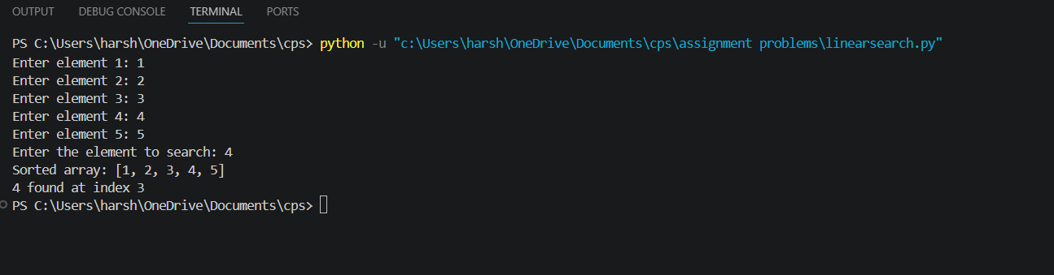
Output:

Explanation:
- binary(arr, key) performs a binary search on the array.
- llimit and rlimit represent the left and right boundaries.
- mid finds the middle element.
- If arr[mid] == key, its index is returned.
- If arr[mid] < key, the search continues in the right half.
- Otherwise, it searches the left half.
- If the element isn't found, it returns -1.
- In main(), the array is automatically sorted before binary search if it isn't already sorted.
- Finally, it prints whether the key was found.

Aim: Code for Binary search if array given is sorted

Program:
def binary(arr, key):

llimit, rlimit = 0, len(arr) - 1

while llimit <= rlimit:
mid = (llimit + rlimit) // 2

if arr[mid] == key: return mid
elif arr[mid] < key: llimit = mid + 1
else:
rlimit = mid - 1

return -1

def main():

n = int(input("Enter the size of the list: "))

if n <= 0:
print("Invalid size") return

arr = []

for i in range(n):
arr.append(int(input(f"Enter element {i+1}: ")))

key = int(input("Enter the element to search: "))

index = binary(arr, key)

if index != -1:
print(f"{key} found at index {index}") else:
print("Element not found") main()

Negative Output:
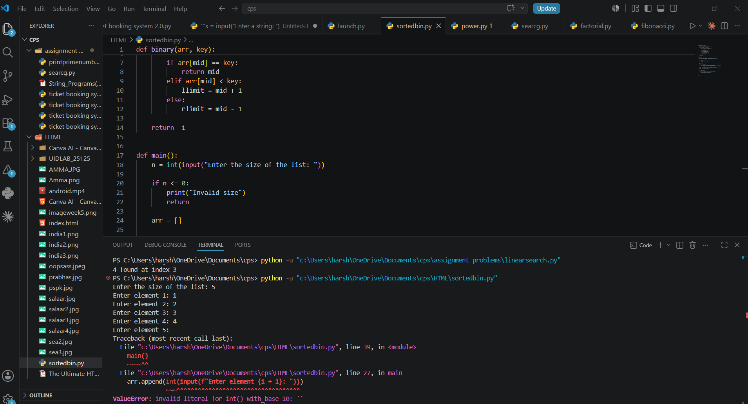

Output:
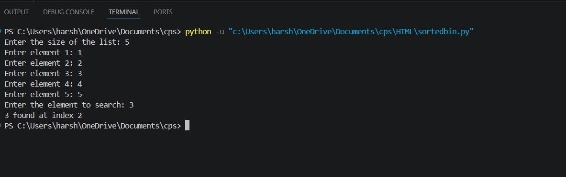

Explanation:
- binary(arr, key) searches for an element using Binary Search.
- llimit and rlimit represent the left and right limits of the array.
- mid calculates the middle index.
- If arr[mid] == key, the index is returned.
- If arr[mid] < key, the search moves to the right half.
- Otherwise, it moves to the left half.
- If the element is not found, -1 is returned.
- In main(), the user enters the array and search value.
- If the array is unsorted, arr.sort() sorts it before binary search.
- Finally, the program prints whether the element was found.

Error Table:

S.no | Error
1. | Invalid literal

WEEK-3

- Write a Python Program to implement Bubble-Sort, where the Input Elements are taken by the User.

Input code: -
#Bubble Sort

def bubbleSort(arr):
n = len(arr)
for i in range(n):
for j in range(0, n - i - 1):

if arr[j] > arr[j + 1]:
arr[j], arr[j + 1] = arr[j + 1], arr[j]
return arr
#INPUT FROM USER
arr = [ ]
n = int(input("Enter size of the list: ")) print("Enter the elements:")
for i in range(n): arr.append(int(input()))
print("Sorted array:")

print(bubbleSort(arr))

Output : -

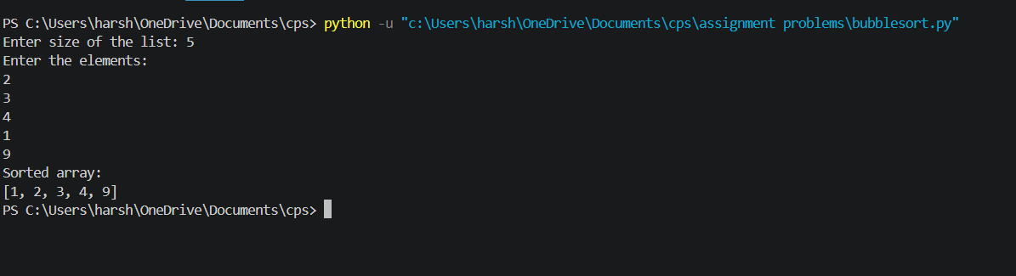

Negative Output: -
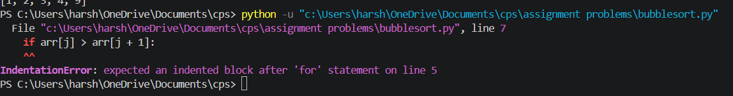
Errors: -
[SYNTAX ERROR. That is I forgot to be keeping the colon (:) in the if loop So, that it raises an Invalid Syntax.

Explanation: -

- Read the size and elements of the list from the user and store them in arr.
- The outer for loop runs through the list multiple times to sort all the elements.
- The inner for loop compares two adjacent elements, arr[j] and
arr[j+1].
- The comparison is made between the current element and the next element to check whether they are in the correct order.
- If the first element is greater than the second, they are swapped using:
arr[j], arr[j+1] = arr[j+1], arr[j]
- After each pass, the largest unsorted element moves towards the end of the list.
- The inner loop compares fewer elements in each subsequent pass because the elements at the end are already in their correct positions.
- After all the passes, the elements are arranged in ascending order, and
return arr returns the sorted list.

- Write a Python Program to implement Insertion-Sort, where the Input Elements are taken by the User.

Input code:
#Insertion –Sort

def insertionSort(arr):
n = len(arr)
for i in range(1, n): key = arr[i]
j = i - 1

while j >= 0 and arr[j] > key: arr[j + 1] = arr[j]
j = j - 1

arr[j + 1] = key return arr
#INPUT FROM USER
arr = [ ]
n = int(input("Enter size of the list: ")) print("Enter the elements:")
for i in range(n): arr.append(int(input())) print("Sorted array:")

print(insertionSort(arr))

Output : -
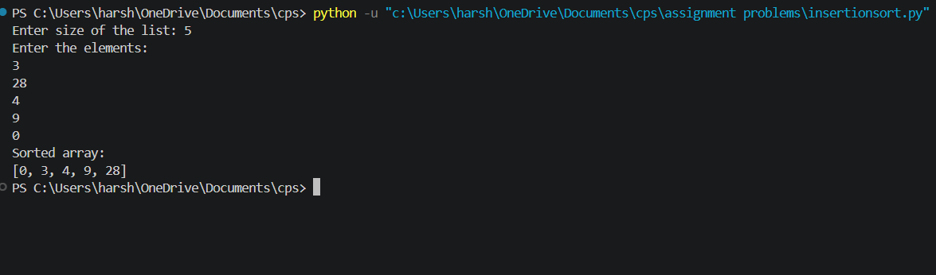

Negative Output: -

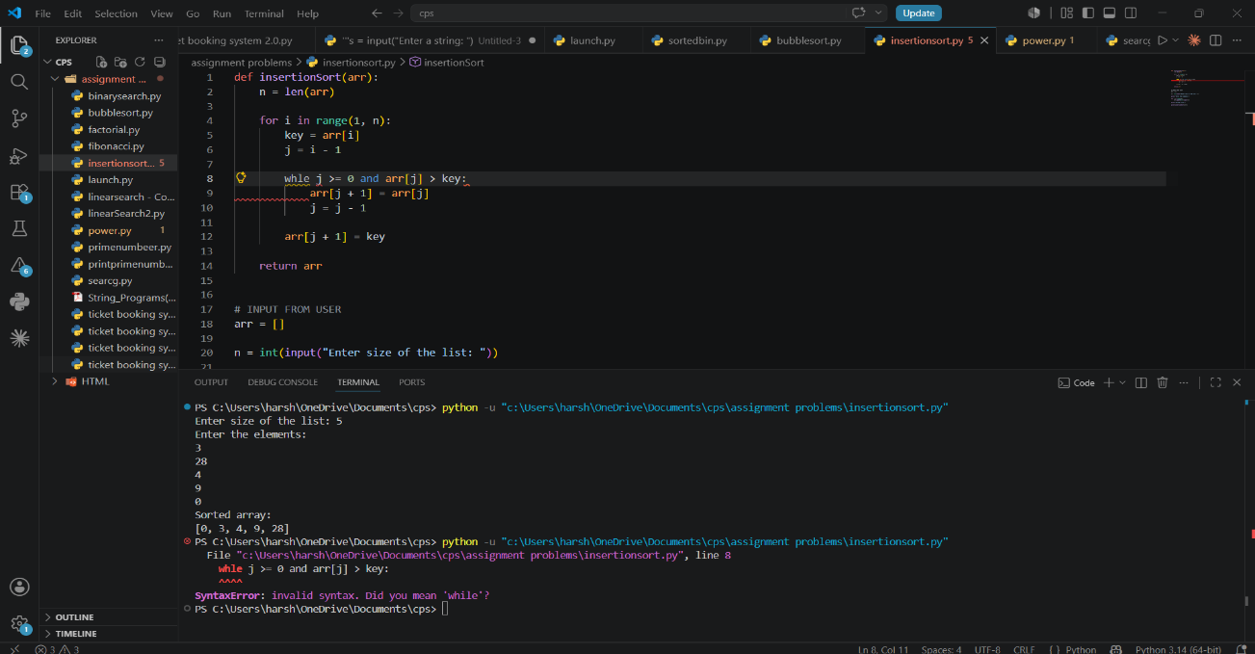

Error: -
In the while loop in the place of 'and' I used comma[,] [SYNTAX ERROR]
after seeing the pop-up I have changed it to and so that I got the desired output...

Explanation: -
- Read the size and elements of the list from the user and store them in arr.
- The for loop starts from the second element, considering the first element as already sorted.
- The current element is stored in a variable called key, which is the element that needs to be placed in its correct position.
- A variable called j is used to point to the element just before the key.
- The while loop compares the key with the previous elements of the sorted part of the list.
- If a previous element is greater than the key, it is shifted one position to the right, and j is moved one position to the left.
- This shifting continues until a smaller element is found or the beginning of the list is reached. Then, the key is inserted into its correct position.
- The process is repeated for all elements, and after all iterations, return arr returns the sorted list in ascending order.

- Write a Python Program to implement Selection-Sort, where the Input Elements are taken by the User.

Input code: -
#SELECTION-SORT

def selectionSort(arr) :

n = len(arr)

for i in range(n): min_index = i

for j in range(i + 1, n):
if arr[j] < arr[min_index]: min_index = j

arr[i], arr[min_index] = arr[min_index], arr[i] return arr

#INPUT FROM USER
arr = [ ]
n = int(input("Enter size of the list: ")) print("Enter the elements:")
for i in range(n): arr.append(int(input()))
print("Sorted array:") print(selectionSort(arr))

Output : -
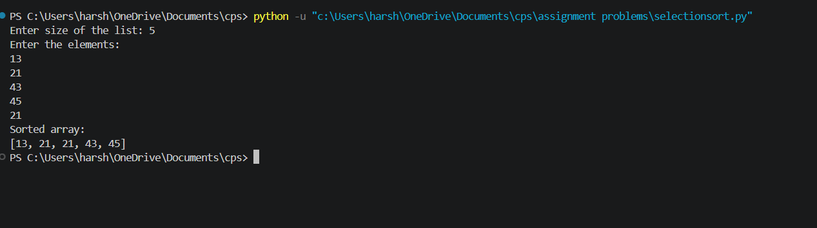

Negative Output: -
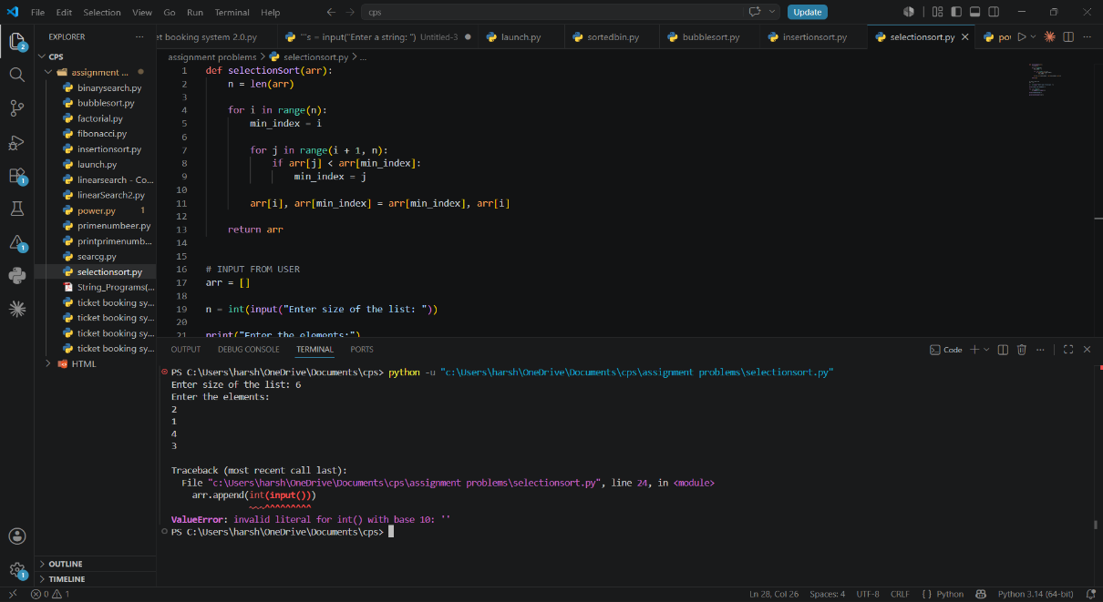
Error: - [value error]
I used ‘>’ symbol in the place ‘<’ so that i get reverse sorted order..
That means it gives the output but the output is not correct.

Explanation: -
- Read the size and elements of the list from the user and store them in arr.
- The outer for loop selects each position of the array one by one, starting from the first position.
- A variable called min_index is used to store the index of the smallest element found.
- The inner for loop compares the current minimum element with the remaining elements of the list.
- If a smaller element is found, its index is stored in min_index.
- After finding the smallest element, it is swapped with the element at the current position using:
arr[i], arr[min_index] = arr[min_index], arr[i]
- This process is repeated until the entire list is sorted and return arr
returns the sorted list in ascending order.

